**How to Use Excel’s Basic Functions!**

**By Alex John & Code for Nepal**

**Part 1 – Summary of Document**

This technical document will outline the basic functions and capabilities of Excel. First, we will look at how to add, subtract, and multiply in Excel through using two fundamental parts of the software – “cells” and the “menu” feature. Next, we will look at how to create a simple scatter plot (also known as a scatter graph). There is a total of 10 steps, and 4 images in this instruction manual. Each of these images are appropriately labeled to enhance your experience with this instruction manual.

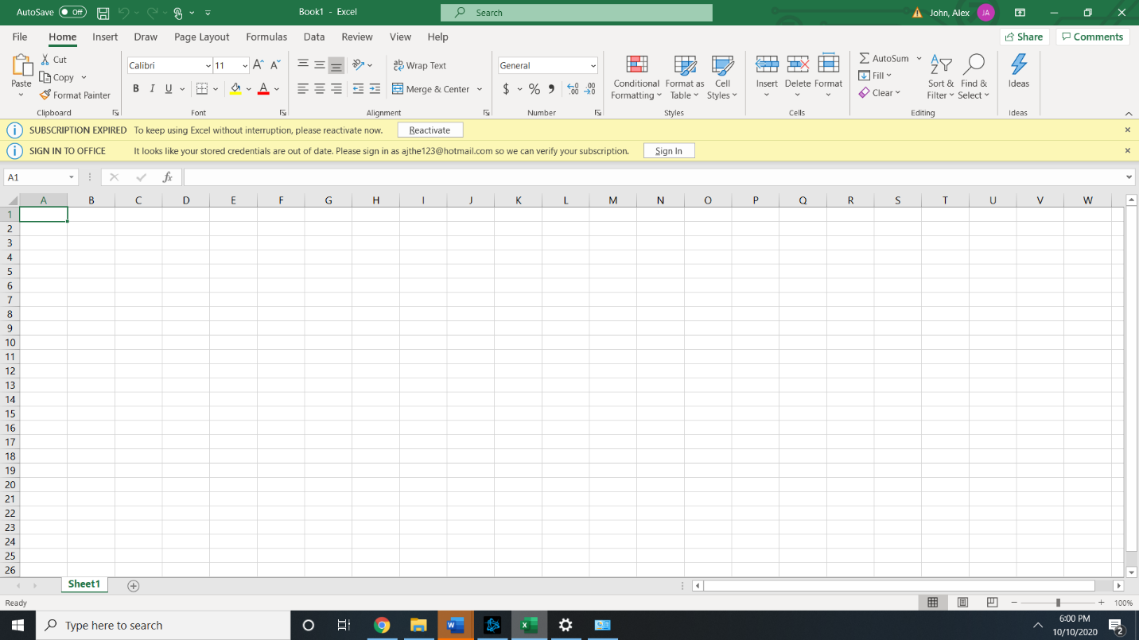As the need for data analysis and manipulation is important in the workforce, my hope is that this document can help you understand how to apply Excel’s basic functions to different quantities of data. One of the benefits of Excel is that it can help you perform multiplication, addition, and subtraction for large amounts of data. In addition, you can analyze and look at trends in the data through creating graphs and plots. I recommend reviewing the other Code for Nepal Excel document first, as it can help you understand the basic tools available to benefit the user experience. If you have any question, or would like more information on Excel, feel free to reach out to the Code for Nepal volunteers.

This is the Excel home screen for the 2016 version of the software!

**Part 2 – Instruction Manual**

**Step 1.)** The first step is to start Microsoft Excel through your start menu. For these instructions, I will be using the 2016 version of Microsoft Excel. There are minor differences between each version of excel, but the instructions and functions should be able to work for each version.

**Step 2.)** When you reach the Excel home screen, click on the first cell (cell A1) as shown in Figure 1. For this manual, we will input a number of ‘8’ in the cell.

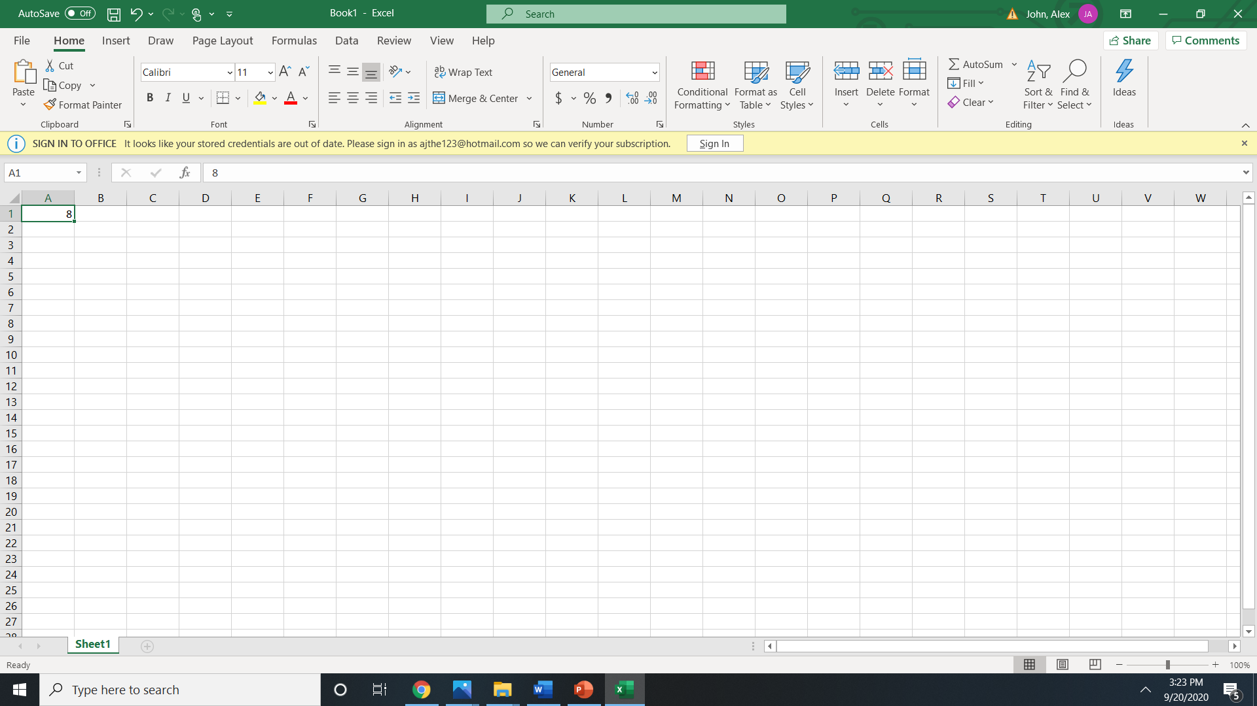

**Side Tip:** In the instructions, you will see several mentions of cell numbers, such as “A1”, “A2, “B2”, these refer to cell column (A, B, C, D, E, and so on) and the cell row (1, 2, 3, 4, 5, and so on). So, cell “A1” refers to the individual cell number in the first row and first column, as shown above.

This is cell A1, because it is the first cell in the first row (1) and first column (A). Notice, we inputted an ‘8’ there.

**Figure 1**: Pictured above is the image described in the second step of this instruction manual.

**Step 3.)** We will now copy that ‘8’ into to the cell directly to the right – Cell B1. To copy the value, click on the original cell (cell A1) and hold the ctrl and c key at the same time. Then, click on Cell B1 and press the ctrl key and v key simultaneously to paste it.

**Step 4.)** To add the cells together, let us go into cell C1 and type ‘=A1+B1’. This should combine the values in cell A1 and B1. The outputted value should read ‘16’ as shown in Figure 2. Please note that for this manual, we are adding values that are next to each other – but you can use Excel Functions across various different cells (for example, cell C3 can be added to the value in cell A8 by typing “=A8 + C3” in an empty cell).

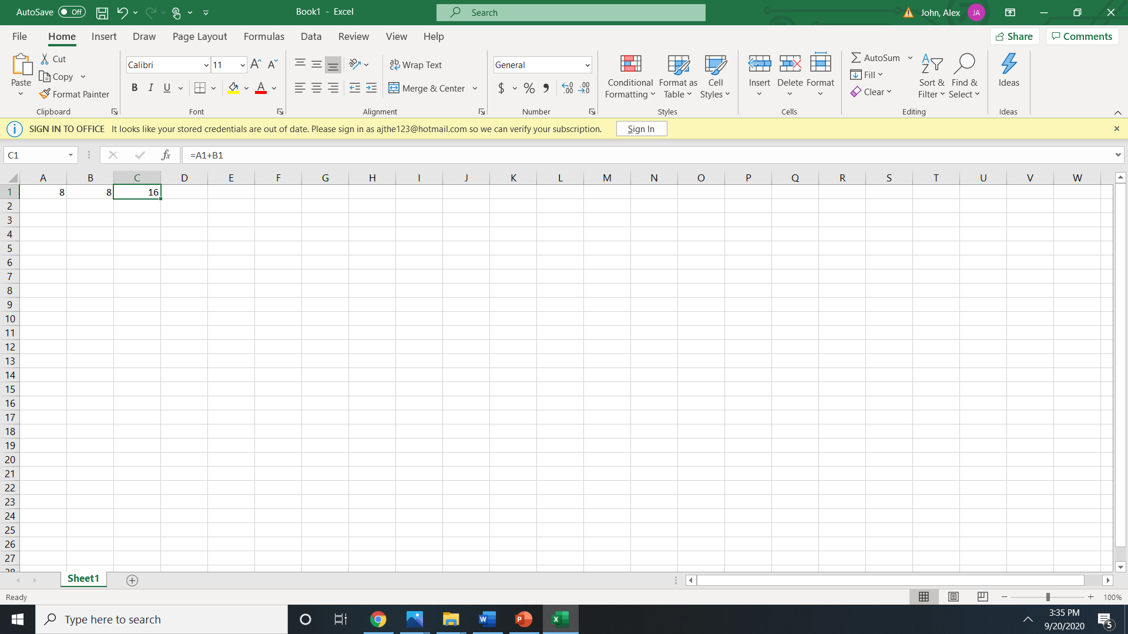

Notice that despite the cell outputting the value of ‘16’, the actual value of the cell is ‘=A1+B1’.

**Figure 2**: Pictured above is the image described in the fourth step of this instruction manual.

**Step 5.)** To multiply the specified cells, type ‘=A1*B1’ in cell C1. The resulting value should read ‘64’.

**Step 6.)** Now let us move onto using graphical tools for Excel. I added some sample values that you can copy as seen in Figure 3. Then, we can click on the ‘insert’ tab next to the ‘file’ & ‘home’ tab.

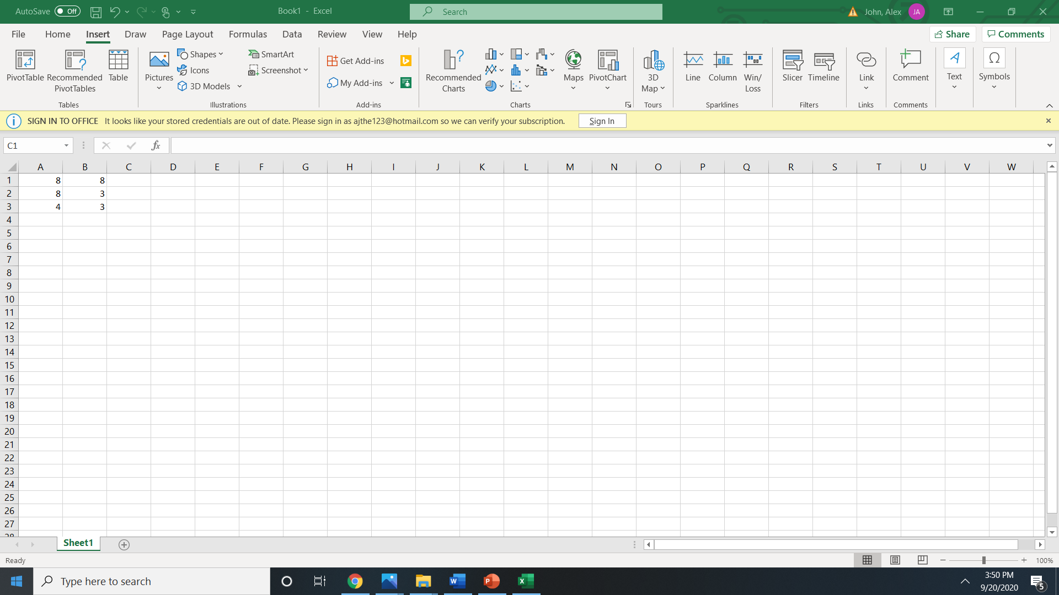

Be sure to copy these values onto your screen.

We are currently on the ‘insert’ tab.

**Figure 3**: Pictured above is the image described in the sixth step of this instruction manual.

**Step 7.)** We can select all the values mentioned in step 5 by placing our cursor over one of the values and holding the left click button on our computer mouses to select multiple values at once.

**Step 8.)** Now, in the ‘insert’ tab area, click on the ‘recommended charts’ button in the top right (which can also be seen in red in figure 3). From there, a scatter plot will appear and select ‘ok’ for the plot to fully display.

**Step 9.)** Now the scatter plot should be displayed near the cells as shown in Figure 4. Notice, by double-clicking ‘Chart Title’, we can change the chart title and write a title that matches our data values.

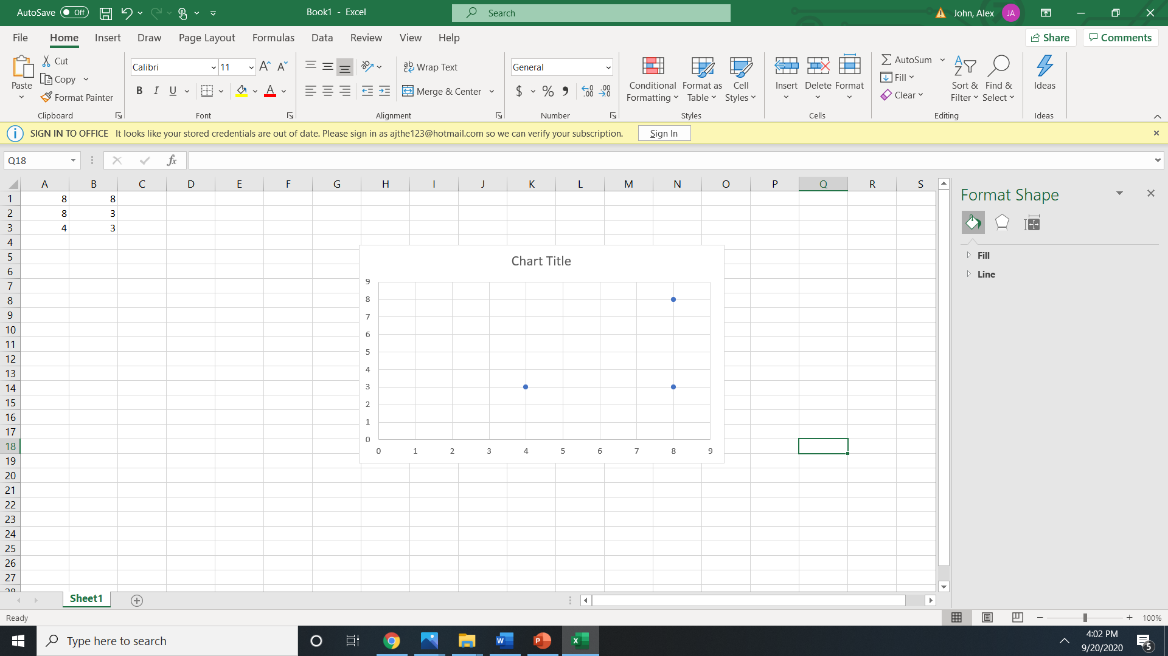

The scatter plot should look like the one shown below. Double click ‘chart title’ to change the title.

**Figure 4:** Pictured above is the image described in the eighth step of this manual.

**Step 10.)** Congratulations! You are now familiar with some of the basic functions and abilities of Excel. Adding, multiplying, subtracting, and creating graphs can be helpful when working in a company or at school. The document will be especially useful for teachers informing students on how to use some of Excel’s common features. Teachers will be able to visualize their students’ progress by referencing the images shown throughout these instructions.